**CHAPTER 1**

**INTRODUCTION**

**1.1 MOTIVATION**

Agriculture sector plays an important role in economic development of India. As compared with development in electronic and automobile sector, development in agriculture sector is very slow. Hence there is a need to come up with some novel techniques so as to fore front the agriculture sector again. As fruits play a vital role in day-to-day life, grading of fruits is necessary in evaluating agricultural produce, meeting quality standards and increasing market value.

Traditionally, classification and grading was performed based on observations and through experience. If the classification and grading is done through manual techniques, the process will be too slow and sometimes it will be error prone. Classification is vital for the evaluation of agricultural produce. Sorting systems are used widely all over the world by manufacturers, exporters, traders and quality control personnel to sort out the produce in order to classify them according to their quality.

Quality by itself is subjective. Quality may be defined either based on external features or internal features. This again may be based on many parameters such as size/weight, shape, colour, surface texture, blemishes etc. Lot of literature can be sited for measurement and/or quantification of many of these parameters based on machine vision techniques and many of them do not consider weight measurement for grading.

We may notice that size is a very important parameter and that weight is closely related to the size, especially for fruits of the same cultivar and grown at the same orchard. Hence weight measurement would be a very close alternative to size computation. Except in the case of high value fruits such as apples, colour or shape do not play a major role in grade classifications and weight assumes greater importance. Growers who export such fruits have to grade them according to weight and pack them appropriately. Also, fruits are delicate materials, so they should be processed via non-destructive techniques.

The literature sited in the later sections is based on dynamic weighing mechanisms, where a load cell is used to weigh the fruits dynamically. Most of the small scale food processing industries make use of simple mechanical weight based system on a conveyor for grading and sorting of fruits without any electronic automation. Such sorting systems employ the technique of force balance arm structure. Also, dynamic weighing involves vibration effects that affect the measurement heavily. There are a few commercial systems available but the cost of these is quite high to be used by the Indian small trader/exporter.

This project is proposed to provide a reliable solution for sorting the fruits based on weight. It deals with Static Weight Measurement (SWM) using embedded system. Embedded system has the advantage of high accuracy, high speed and low cost. This project deals with designing, developing a system for reliable weight measurement by stationary mechanism and evaluating the performance of the system. This proposed system will have a good prospect of application in fruit quantity detection and sorting areas.

**1.2 EMBEDDED SYSTEM**

An embedded system is a special-purpose computer system, which is completely encapsulated by the device it controls. An embedded system has specific requirements and performs pre-defined tasks, unlike a general-purpose Personal Computer (PC). An embedded system is a programmed hardware device. A programmable hardware chip is the raw material and it is programmed with particular applications. Embedded systems are a combination of hardware and software, which facilitates mass production and variety of application.

**1.2.1 Components of Embedded System**

**1. Hardware**

Processors, timers, interrupt controller, I/O devices, memories, ports etc.

**2. Main Application Software**

This performs concurrently a series of tasks or multiple tasks.

**3. Real Time Operating System (RTOS)**

RTOS defines the way the system works. It supervises the application software. It sets the rules during the execution of the application program.

**1.2.2Embedded System Hardware and Software**

The hardware includes,

* Power source
* Clock oscillator
* Real Time Clock (RTC)
* Reset circuit , Power Up reset , Watchdog Timer reset
* Memory
* I/O Ports , I/O buses
* Interrupt handler
* DAC
* ADC
* LCD/LED display
* Keypad and Keyboard

The fig 1.1 shows the hardware of embedded system.



**Figure 1.1 Embedded System Hardware**

Some of the software used for embedded system are

* C
* C++
* Dot Net

**Compiler**

* Ride
* KEIL

**1.2.3 Applications of Embedded System**

* Household appliances
* Integrated systems in aircrafts and missiles
* Cellular telephones
* Calculators
* Medical equipment
* Video games
* Engine controllers in automobiles
* Electric and electronic motor controllers

**CHAPTER 2**

**LITERATURE SURVEY**

**2.1 INTRODUCTION**

The various data collected from below literature survey is quite useful in various ways for developing this project. In the same way each and every paper has its own advantages and disadvantages. In which some of the ways to overcome the drawbacks is being discussed in this design and implementation of stationary weighing mechanism of citrus fruits using ardunino.

**2.2 LITERATURE REVIEW**

Loukik P. Narawade, Suresh S. Shendage,(2015)[5] “Weightbased Fruit Sorting System”,International Journal of Research in Computer Science and Management Studies,volume 3,Issue 3, March 2015.

The proposed sorting system offers an economical solution for automated fruit sorting practices. By dealing with an automated material handling system, it aims in classifying the fruits by weight which is coming on the conveyor by moving the fruits to its respective packing place. For sorting using weight as a parameter, the load cell arrangement is used. ATmega16 microcontroller is used to control the sequence of operations performed by the system. This system weighs the fruits dynamically, which introduces error in the measured weight. This system is fixed in the sense that no additional equipment such as stepper motor can be included in between. This system is less reliable.

B. Sundaresan, R. Sridhar and S. Md. Iqbal. (2011)[1]“Retrofit Automation of Weight based Sorter with Dynamic Electronic Weighing for Mangoes.” Trends in Industrial Measurements & Automation, 2011.TIMA2011*.* 7th International Conference on, Jan 6 – 8, 2011, pp.491-494.

The retrofitted system consists of an electro-mechanical conveyor driven by an AC squirrel cage induction motor. Proximity switches are installed for object detection. Solenoid valve actuators are interfaced for dropping the graded fruits into the respective bins. The system employs the technique of force balance arm structure. The smart load cell delivers a completely filtered, scaled, digitised and isolated output signal through RS422/RS485 serial port for direct interface to a PC system. They operate with high sampling rate. Glitch and dropout in measurement occurs as the weight keeps on changing.

Khojastehnazhand, Mostafa, Mahmoud Omid, and Ahmad Tabatabaeefar.(2010) [3] "Determination of tangerine volume using image processing methods.”International Journal of Food Properties 13.4 (2010): 760-770.

This sorting system is developed to increase the quality of food products made from fruits. The sorting process depends on capturing the image of the fruit and analysing this image using image processing techniques to discard defected fruits. The main emphasis is to do the quality check with a short span time so that maximum number of fruits can be scrutinised for quality in minimum amount of time. For sorting using colour, after capturing the fruit’s side view image, some fruit characteristics are extracted by using detecting algorithms. This system performs the sorting and quality check using MATLAB software. The MATLAB language is used to mathematically analyse the colour of the fruit. The Graphical User Interface (GUI) displays the characteristics (colour components, width and height) of the image captured and also the number of accepted and rejected fruits. However this system is time consuming and also requires a large number of hardware components. Eventually, the system imposes a delay in processing the fruits.

U Ahmad, S Mardison, R Tjahjohutomo and A. Nurhasanah, (2010)[8]"Development of automatic grading machine prototype for citrus using image processing", Australian Journal of Agriculture Engineering, no. 5, pp. 165-169, 2010

In recent years, automatic visual inspection system has become useful tool in industrial process. The citrus fruit sorting and grading process has now been completely automated with the exception of the final stage of classification concerned with visual inspection. Due to the growing demand of quality citrus fruit, an automated and reliable identification and classification mechanism in order to handle the bulk of data is implemented. Human vision sometimes leads to mismatch between the fruits. Using machine vision system, it will be simple to reduce human effort and achieve a better output. The objective of this project is to assess the fruit by color grading. In this paper we describe an integrated system developed for the sorting on citrus fruit and for the color grading of the defected fruits. The result suggests that the performance is adequate to provide the basis for a viable commercial visual inspection system. The following project aims at implementing such an automated system using image processing with images of citrus fruit as a basis of classification depending on its color. The goal of the inspection is not to give a statistical analysis of the production but to classify every citrus fruit into quality constant batches.

**2.3 CONCLUSION**

This Chapter gives the detailed study of literature survey which is useful to complete the work.

**CHAPTER 3**

**PROJECT DESCRIPTION**

**3.1 OBJECTIVE**

To design and develop a system for on-line grading and sorting of fruits using Maltese Cross Principle (MCP) based Static Weight Measurement(SWM) and also to evaluate its performance and repeatability.

**3.2 PROPOSED METHODOLOGY**

Nowadays, industrial automation is increasingly getting important in the sorting process because computers or machines are capable of handling repetitive task quickly and effectively. This project aims at replacing man power with machine. Usually a lot of human error occurs during the process of fruit sorting. Therefore this system is proposed to overcome those errors.

The existing systems for sorting the fruits were based on dynamic weighing. Dynamic weighing has a lot of drawbacks which includes,

* Less accuracy
* Poor repeatability
* Vibration effects

Stress on the conveyor, giving large variations in results.

In this project, we propose an optimal solution for sorting the fruits based on weight by employing SWM***.*** This project comprises of two sections:

* Mechanical Structure
* Electronics Segment

**3.2.1 Mechanical Structure**

The mechanical section consists of an indexer which helps in the implementation of SWM. This indexer is designed based on the MCP. MCP is also referred as Geneva mechanism. The Geneva wheel, or Maltese cross, is a cam like mechanism that provides intermittent rotary motion & is widely used in both low and high-speed machinery. Geneva is the simplest and least expensive of all intermittent motion mechanisms. The Geneva Mechanism is shown in Fig 3.1.

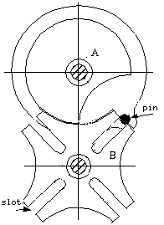

**Figure 3.1 Geneva Mechanism**

The mechanical assembly that is designed based on the MCP consists of the following. The Fig 3.2 shows the Geneva Wheel and Fig 3.3 shows the Crank and Fig 3.4 shows the Shaft Pin.



**Figure 3.2 Geneva Wheel**



**Figure 3.3 Crank**



**Figure 3.4 Shaft Pin**

**3.2.2 Electronics Segment**

Electronics segment consists of electronic devices like IR sensor, Arduino and Liquid Crystal Display (LCD). This section deals with,

* Fruit indexing mechanism
* Interfacing of weighing machine with Arduino
* Data storage in PC.

Fruits are indexed using IR sensor which is interfaced with Arduino. Fig 3.5 shows the IR Sensor Module.



**Figure 3.5 IR Sensor Module**

This is performed to determine the total number of fruits being processed. The digital output of the weighing machine is loaded into an Arduino which then displays the weight of each fruit on the LCD. The fruit count along with their respective weight is stored in the LCD.

The Arduino Uno R3 board is shown in Fig 3.6



**Figure 3.6 Arduino Uno R3**

**3.3 BLOCK DIAGRAM**

The block diagram consists of the following blocks:

* IR sensor module
* Indexer platform with weighing machine
* Arduino UNO #1
* Arduino UNO #2
* PC

The fruits placed in the indexer is sensed by the IR sensor module.The weight of the fruit is measured by weighing machine by making it to be static for 1 second. The signal is sent to the Arduino where the count is stored and displayed in Liquid Crystal Display. The data is then transferred to PC and the readings are displayed.The block diagram of Static Weighing Machine (SWM) is shown in fig 3.7.

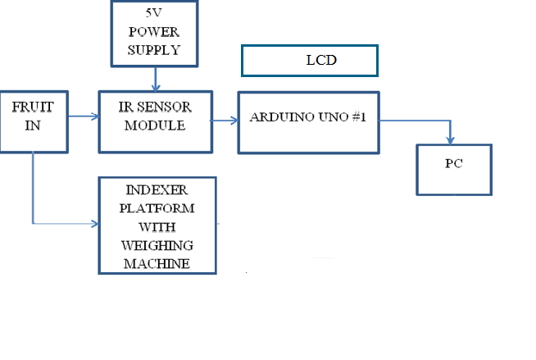

**Figure 3.7 Block diagram of Static Weighing Machine**

**3.4 FLOW CHART**

The fruits from the conveyor belt passes into the indexing platform where the weight is being measured. The frequency of each fruit is displayed in the LCD and the it is converted into its corresponding weight. The data is then stored in the PC by using PLX-DAQ spreadsheet. The data analysis is done and the standard deviation is calculated. The fruits are then neglected based on the limits. Fig 3.6 shows the process of Static Weighing Machine.

**START**

**INDEXING OF FRUITS**

**WEIGHT AND FREQUENCY MEASUREMENT**

**DATA STORAGE IN PC**

**LCD**

**DATA ANALYSIS**

**DEVIATION MINIMISATION**

**STOP**

**Figure 3.8 Process in STATIC WEIGHING MACHINE (SWM)**

**CHAPTER 4**

**MECHANICAL STRUCTURE**

**4.1 CONVEYOR SYSTEM**

The system is built with a conveyor to singulate the fruits, which then transfers them onto the indexer. The conveyor is driven by chain drive whose speed can be varied using an AC drive control unit. The throughput of the conveyor can vary. But this may be limited to vagaries of the mechanical imbalances and the computational overheads on the system CPU.

**4.2 INDEXER**

In order to attain the SWM, MCP is designed and constructed for generating indexing stages. Fig 4.1 shows the Maltese Cross Mechanism. Fig 4.2 shows the mechanical assembly using Maltese Cross Principle and Fig 4.3 shows the Indexing Arrangement using Octagonal Baffle Plate.



**Figure 4.1 Maltese Cross Mechanism**

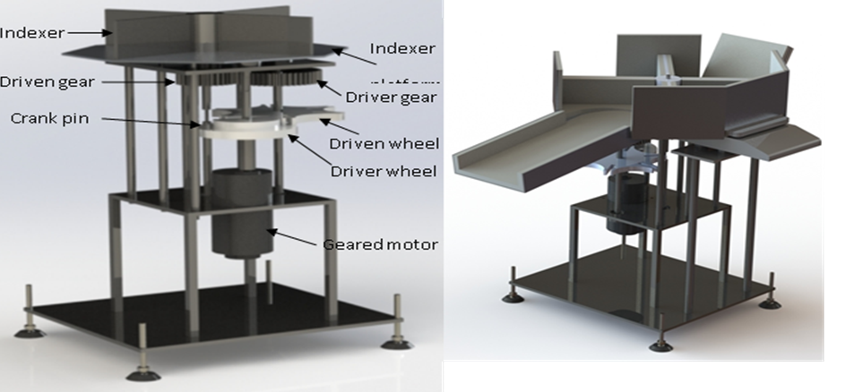

**Figure 4.2 Mechanical Assembly using MCP**

Initially octagonal shaped baffle plates were provided to guide the fruits.

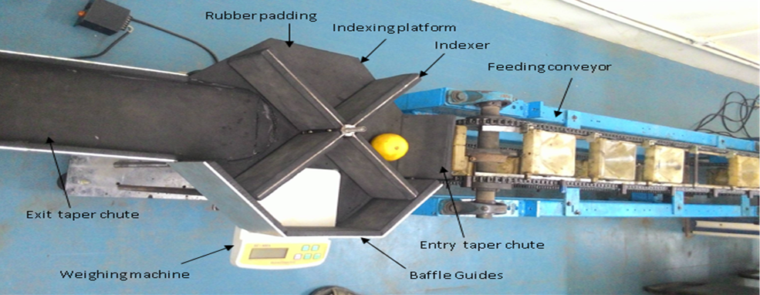

**Figure 4.3 Indexing Arrangement using Octagonal Baffle Plate**

But it was observed that the fruits were caught between the indexer and the baffle plate construction at the corner positions. Also a jerk was observed in the indexer during indexing.

So circular baffle plate was made which allowed a smooth transition of fruits from one segment to other segment. By providing locking spacer, the jerk was arrested.

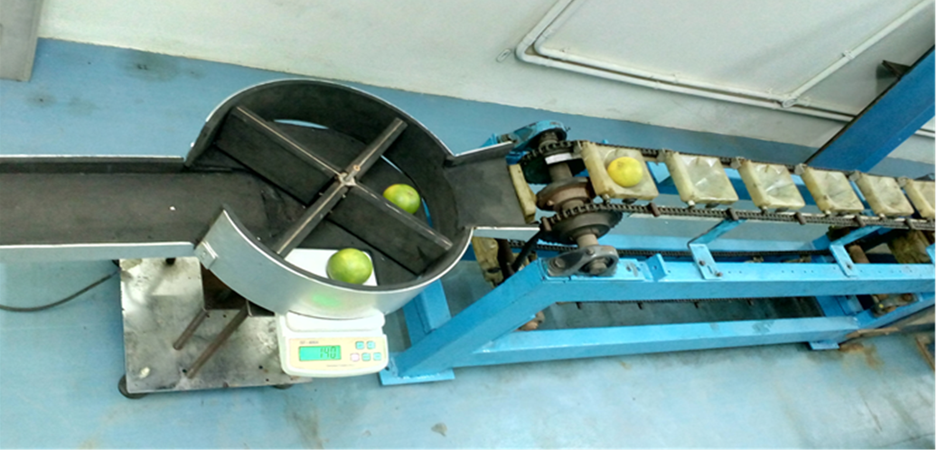

**Figure 4.4 Indexer Platform with Circular Baffle Plate**

At times, the fruits were rolling away from the weighing platform to the sides of the indexer pocket during indexing. Therefore, the indexer was redesigned by providing pockets matching the weighing platform.

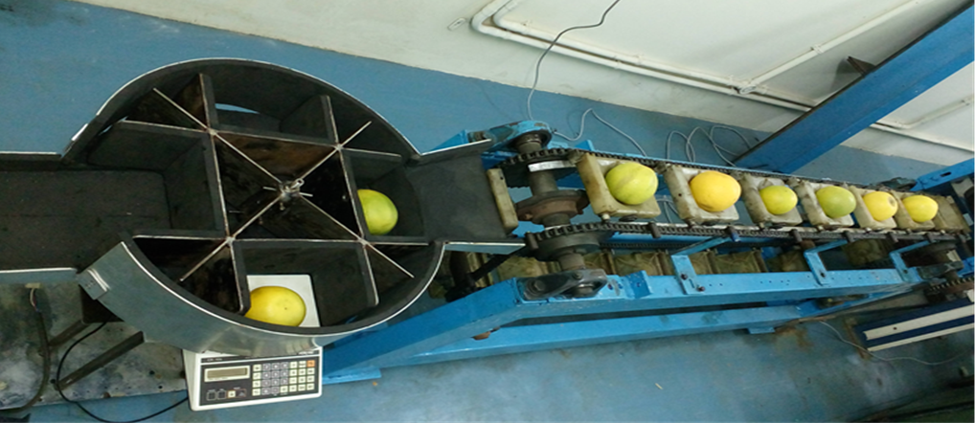

**Figure 4.5 Arrangement of Modified Indexer**

The modified indexer has an indexer platform which is divided into four segments. The fruit from the feeding conveyor is received in the first segment of the indexer platform and then indexed to the second segment. The weight of the fruit is measured by the weighing machine fitted over vibration free mounts in the second segment and then indexed to the third segment. A simple capacitive type weighing machine with the weighing capacity of 1gram to 1000grams is used for the weight measurement. An entry taper chute is provided for transfer of fruits from the feeding conveyor onto the indexer platform. Baffle plates are provided on the periphery of the indexer platform to avoid falling of the fruits, when the indexer pushes the fruits from one index position to the next. This was done to ensure that the fruits are always placed on the weighing machine platform during indexing. Thus this structure allows the fruits to remain stationary on the weighing platform during their transit.

**CHAPTER 5**

**ELECTRONICS SEGMENT**

The functions of the electronics segment are to,

* Index each of the fruits which are being processed and display them using a LCD.
* Measure the weight of each fruit using a Digital Weighing Machine (DWM) and display the respective weight on the LCD.
* Analyse the measured weight data.
* Store the results in a PC.

The various devices in the electronics section are,

* IR sensor
* LCD
* DWM
* PC
* Arduino UNO

**5.1 IR SENSOR**

The IR sensor is a general-purpose proximity sensor. The module consists of an IR emitter and IR receiver pair. An IR sensor is an electronic device that is used to sense some of the aspects of the surroundings. The IR sensor can measure the heat of an object as well as detect the motion. These type of sensors measures only infrared radiations.Fig5.1 shows the Infrared object detection sensor.



**Figure 5.1 Infrared Object Detection Sensor**

**5.1.1 Introduction and Overview**

The IR sensor module consists of an IR emitter and an IR receiver pair. Fig 5.2 illustrates the object detection by IR sensor.

**IR Transmitter**

**Object Body**

**IR Receiver**

**Figure 5.2 Object Detection by IR Sensor**

The emitter is simply an IR LED (Light Emitting Diode) and the detector is simply an IR photodiode which is sensitive to the IR light of the same wavelength as that emitted by the IR LED. The high precision IR receiver always detects the IR signal.

**5.1.2 Features**

The product features include,

• 5V powered, low current consumption, less than 10mA.

• 3 pin interface which are signal, GND and 5V.

• Small LED as indicator for detection status.

•Obstacle detection up to 8 cm

•Adjustable sensing range (2cm – 8cm).

•Small size makes it easy to assembly.

• Single bit output

•Compatible with all types of microcontrollers and Arduino.

**Table 5.1.1 Specifications of IR Sensor**

|  |  |
| --- | --- |
| **Parameter** | **Value** |
| Operating Voltage | +5V DC regulated |
| Object detection | Indicated by active high output |

**Table 5.1.2 Pin Specifications of IR Sensor**

|  |  |  |
| --- | --- | --- |
| **Pin** | **Name** | **Details** |
| 1 | OUT | Active High Output |
| 2 | GND | Power Supply Ground |
| 3 | +5V | Power Supply Input |

**5.1.3 Circuit Diagram**

An infrared sensor circuit is one of the basic and popular sensor modules in an electronic device. This sensor is analogous to human’s visionary senses which can be used to detect obstacles and it is one of the common applications in real time. Fig 5.3 shows the circuit diagram of IR sensor Module.

This circuit comprises of the following components,

* LM358 IC
* IR transmitter and receiver pair
* Resistors of the range of Kilo ohms (KΩ)
* Variable resistors
* LED

[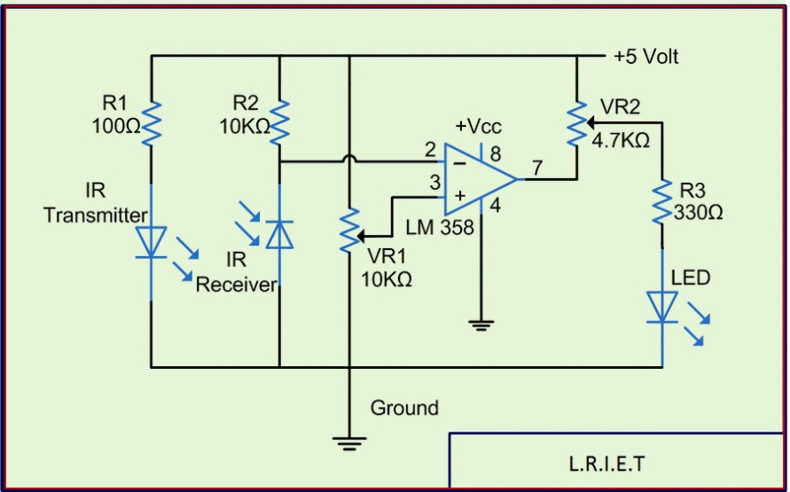](http://www.elprocus.com/wp-content/uploads/2015/01/IR-sensor-circuit-diagram.jpg)

**Figure 5.3 Circuit of the IR Sensor Module**

**5.1.4 Operation**

The transmitter section includes an IR sensor, which transmits continuous IR rays to be received by an IR receiver module. An IR output terminal of the receiver varies depending upon its receiving of IR rays. Since this variation cannot be analyzed as such, this output is fed to a comparator circuit. Here an operational amplifier (Op-Amp) of LM 339 is used as a comparator circuit. When the IR receiver does not receive a signal, the potential at the inverting input goes higher than that non-inverting input of the comparator IC (LM339). Thus the output of the comparator goes low, but the LED does not glow. When the IR receiver module receives signal to the potential at the inverting input goes low. Thus the output of the comparator (LM 339) goes high and the LED starts glowing. Resistor R1 (100 ), R2 (10k ) and R3 (330) are used to ensure that minimum 10 mA current passes through the IR LED Devices like Photodiode and normal LEDs respectively. Resistor VR2 (preset=5KΩ) is used to adjust the output terminals. Resistor VR1 (preset=10KΩ) is used to set the sensitivity of the circuit.

**5.1.5 Indexing Mechanism**

In this project, the IR sensor is interfaced with Arduino UNO for the purpose of counting. The IR sensor detects the presence of fruits and gives the count accordingly. The IR sensor module is calibrated in a manner that whenever a fruit is detected, the output of the IR sensor goes HIGH; else its output is LOW. The count is also displayed on a LCD which is interfaced with Arduino UNO. 5

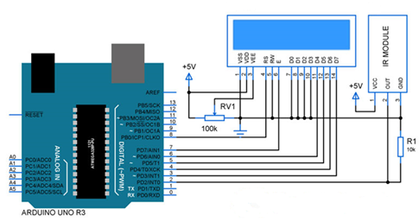

**Figure 5.4 Interfacing IR Sensor with Arduino Uno**

The above Fig 5.4 illustrates the interfacing of IR sensor with Arduino.Here the IR sensor output is connected to the external interrupt pin 2 of the Arduino. So whenever the sensor gives the output as HIGH, the Arduino increases the count by 1. A 16×2 LCD is used as a display here for the number of fruits. A pull down resistor is used to keep the output low when no fruit is encountered by the sensor.

**5.1.6 Algorithm to Code**

1. Initialize LCD display to print your data.

2. Set up external interrupt on pin 2 of the Arduino with the sensor.

3. Write the Arduino coding to increase the count by 1 whenever an interrupt is encountered.

4. Display the count value in the LCD for the user.

**5.2 LCD**

An LCD is a small, low cost display. LCDs with a small number of segments, such as those used in digital watches and pocket calculators, have individual electrical contacts for each segment. An external dedicated circuit supplies an electric charge to control each segment. Fig 5.5 shows Liquid Crystal Display.

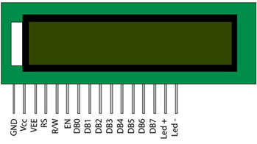

**Figure 5.5 16x2 LCD**

Small monochrome displays such as those found in personal organizers or older laptop screens have a passive-matrix structure employing Super-Twisted pneumatic (STN) or Double-layer STN (DSTN) technology, the latter of which addresses a colour-shifting problem with the former and Colour-STN (CSTN) wherein colour is added by using an internal filter. Each row or column of the display has a single electrical circuit.

The pixels are addressed one at a time by row and column addresses. This type of display is called passive-matrix addressed because the pixel retains its state between refreshes. As the number of pixels increase, this type of display becomes less feasible. Very slow response times and poor contrast are the typical characteristics of passive-matrix addressed LCDs.

High-resolution colour displays such as modern LCD computer monitors and televisions use an active-matrix structure. A matrix of Thin-Film Transistors (TFTs) is added to the polarizing and colour filters. Each pixel has its own dedicated transistor, allowing each column line to access one pixel. When a row line is activated, all of the column lines are connected to a row of pixels and the correct voltage is driven onto all the column lines.

**5.2.1 Features**

**Table 5.1.3 Features of LCD**

|  |  |
| --- | --- |
| **Parameter** | **Details** |
| Display construction | 16 characters*2 lines |
| Display mode | TN/STN |
| Display type | Positive reflective |
| Backlight | LED/4.2VDC |
| Connector | Pin |
| Operating temperature | Indoor |
| Driving voltage | Single power |
| Driving method | 1/16 duty, 1/4 bias |
| Type | Chip On Board (COB) |
| Number of data line | 8-bit parallel |

**5.2.2 Pin Details**

**Table 5.1.4 Pin Description of LCD**

|  |  |  |
| --- | --- | --- |
| **Pin** | **Function** | **Name** |
| 1 | Ground (0V) | Ground |
| 2 | Supply voltage 5V | $$V_{CC}$$ |
| 3 | Contrast adjustment | $$V_{EE}$$ |
| 4 | Selects command register when low; and data register when high | Register Select |
| 5 | Low to write to the register; High to read from the register | Read/Write |
| 6 | Sends data to data pins when a high to low pulse is given | Enable |
| 7 | 8-bit data pins | DB0 |
| 8 | 8-bit data pins | DB1 |
| 9 | 8-bit data pins | DB2 |
| 10 | 8-bit data pins | DB3 |
| 11 | 8-bit data pins | DB4 |
| 12 | 8-bit data pins | DB5 |
| 13 | 8-bit data pins | DB6 |
| 14 | 8-bit data pins | DB7 |
| 15 | Backlight $V_{CC}$ (5V) | Led+ |
| 16 | Backlight ground (0V) | Led- |

**5.2.3 Interfacing LCD with Arduino**

A LCD is a video display that utilizes the light modulating properties of liquid crystals to display pictures or text on a screen. One way to utilize an LCD is with an Arduino microcontroller. By wiring an Arduino microcontroller to the pins of an LCD display, it is possible to program the microcontroller to display a desired text string or image on the screen. Interfacing an Arduino microcontroller with an LCD display consists of two parts, wiring and programming.

**(A) Wiring**

A typical LCD display consists of 16 pins that control various features of the screen. The Arduino microcontroller can output voltages of either 5 V or 3.3 V, so the LCD can be powered by wiring VSS and VDD to the ground and 5 V pins on the microcontroller. It is possible to adjust the contrast of the screen by wiring a variable resistor to Vo located at pin 3 on the screen. The RS, R/W, and E pins are wired to pins 12, ground, and 11 respectively on the Arduino. The LCD screen can operate in both 8-bit mode and 4-bit mode.

To interface with the LCD in 4-bit mode, the Arduino needs to be connected to pins DB4-DB7, which will connect to digital output pins 5-2 respectively. Pins 15 and 16 on the LCD screen are used to power a backlight in the screen. In order to power, the backlight pin 15 should be connected to ground while pin 16 should be connected to the 5V output of the Arduino. To power the Arduino, a 9V battery can be connected to $V_{in}$ and ground pins on the Arduino.

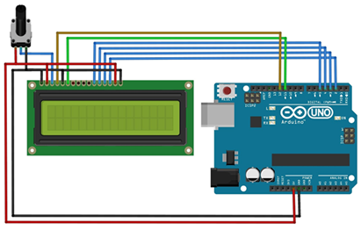

**Figure 5.6 Wiring Schematic for LCD-Arduino Interfacing**

Fig 5.6 shows the wriring schematic diagram of LCD-Arduino Interfacing. If such power source is unavailable, the Arduino can be powered by using its USB connection with a computer.

**(B)Programming**

Once all of the wiring is complete, the Arduino can write text to the LCD via programs that are loaded onto the microcontroller. Programs utilizing the C or JAVA programming language can be uploaded to the microcontroller via free open source software made by Arduino. A library made by Arduino called “LiquidCrystal” can be downloaded and used in any program written to interface with the LCD display. The “LiquidCrystal” library contains a variety of built in functions that allow an Arduino to control an LCD. These functions allow the user to do things like print text strings to the screen, initialize the screen cursor to a certain pixel, scroll the screen left or right, clear the display, as well as a variety of other things.

**5.3 DIGITAL WEIGHING MACHINE (DWM)**

Each of the fruits from the conveyor is weighed using a weighing machine. The weighing machine used in this project is a digital one. The weight of the fruit is measured by the weighing machine fitted over vibration free mounts in the second segment of the mechanical assembly and then indexed to the third segment. A simple capacitive type weighing machine with the weighing capacity of 1gram to 1000grams is used for the weight measurement. Fig 5.7 shows the Capacitive type Digital Weighing Machine

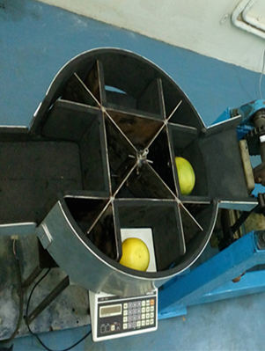

**Figure 5.7 Capacitive Type DWM**

This is the crucial part of the proposed project where the accuracy of the measured weight and the speed of transferring the weight data to the Arduino UNO are the trade-off. The DWM is interfaced with LCD to display the weight of each fruit.

During the process of measuring the weight of the fruits on-line, we found that the DWM transferred around 10 values for each fruit placed on it. This may have some erroneous data. So in order to nullify this problem, we came out with the solution of applying 2σ limits to the set of readings obtained for a fruit.

**Table 5.1.5 Set of Weight Obtained from DWM for a Fruit**

|  |  |
| --- | --- |
| **Fruit number** | **Weight measured** |
| 1 | 23 |
| 2 | 49 |
| 3 | 49 |
| 4 | 49 |
| 5 | 49 |
| 6 | 49 |
| 7 | 49 |
| 8 | 67 |
| 9 | 49 |
| 10 | 67 |

**5.3.1 Calculation**

The sample set of weight data for a fruit is tabulated above. Firstly, average is taken for the obtained set (i.e. 10 readings per fruit). The average weight in this case is,

$W_{av }$ = $\frac{23+49+49+49+49+49+49+67+49+67}{10}$ = 50grams

The Standard Deviation is calculated as

σ = 2 / n

σ= [(289+1+1+1+1+1+1+289+1+289) /10]1/2

σ= 11.46

Upper Control Limit, UCL = $\overline{x}$ +2σ

Lower Control Limit, LCL = $\overline{x}$- 2σ

UCL= 50+2(11.46) = 72.93

LCL= 50-2(11.46) = 27.08

The values that are greater than UCL and less than LCL are removed and the new average is calculated from the resulting data.

The new Average Wnav = [(49+49+49+49+49+49+67+49+67)/9]

Wnav = 53grams.

The coding for calculating the actual weight from the set of weight values is written and loaded into the Arduino. The “RunningAverage” is the library that is used for the weight calculation. The Arduino makes a synchronisation between the fruit’s index value and the weight calculated.

The Arduino is used here for the purpose of storing the data in an excel sheet. In this project, we use software called “PLX-DAQ” for loading the index of the fruit along with its weight into the excel sheet.

**5.4 PC**

A PC is used for storing the index of the fruits along with their weight. For a better visualisation of the captured data, they are stored in a spread sheet.

Fig 5.8 illustrates the data acquisition in PLX-DAQ Spreadsheet.

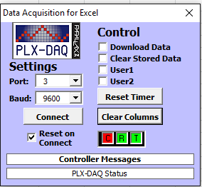

**Figure 5.8 Data Acquisition in Excel**

PLX-DAQ is supported by Arduino UNO. The coding for transferring the data is compiled and loaded into the Arduino. The baud rate has to be initialised in the coding within the Arduino and the same baud rate has to be specified in the PLX-DAQ software. Also, the port for serial communication has to be indicated both in the Arduino and the PLX-DAQ software. Eventually, the data are serially transferred onto the spread sheet.

**5.5 ARDUINO**

**5.5.1 Steps for Connecting Arduino**

1. Connect Arduino Board to the system using USB and to the weighing Machine using BNC connector.

2. Open the Main Code from the desired folder.

3. Open Start-->All Programs-->Parallex.inc-->PLX-DAQ Spread sheet.

4. Press "OK" to continue.

In the small window that opens,

5. Select the Communication Port (3/4). To find the communication port.

6. Right Click My Computer icon --> Device Manager/Manage --> Ports --> Arduino Uno (COM __).

7. Select the Baud Rate (Set 9600).

8. Press Connect and confirm all the "C","R","T" are in green colour to get the data in excel sheet.

9. After successful testing press, "Disconnect" to stop receiving data from Arduino Uno.



**Figure 5.9 Port Selection**



**Figure 5.10 Selecting the Board**

The above figures 5.9 and 5.10 shows the Port Selection and Selecting the Boards.

**CHAPTER 6**

**SOFWARE REQUIREMENTS**

**6.1 INTRODUCTION TO ARDUINO UNO**

The Arduino Uno is a microcontroller board based on the ATmega328. It has 14 digital input/output pins (of which 6 can be used as PWM outputs), 6 analog inputs, a 16 MHz crystal oscillator, a USB connection, a power jack, an ICSP header, and a reset button. It contains everything needed to support the microcontroller.

The Uno differs from all preceding boards in that it does not use the FTDI USB-to-serial driver chip.

**6.1.1 Characteristics**

* 32 KB flash memory
* 1 KB EEPROM
* 2 KB SRAM
* 16 MHz Clock
* Inputs and Outputs
* 14 digital Inputs/Outputs
* 6 analog Inputs
* 6 PWM-Outputs
* $I^{2}$ C-Bus, serial Bus (TX/RX)

**6.1.2 Specification**

**Table 6.1.1 Technical Specification of Arduino UNO R3**

|  |  |
| --- | --- |
| **Parameter** | **Detail** |
| Microcontroller | ATmega328 |
| Operating voltage | 5V |
| Input voltage | 7-12V |
| Digital I/O pins | 14 (of which 6 provides PWM output) |
| Analog input pins | 6 |
| DC current per I/O pin | 40mA |
| DC current for 3.3V pin | 50mA |
| Flash Memory | Bootloader |
| SRAM | 2KB |
| EEPROM | 1KB |
| Clock speed | 16MHz |

**6.1.3 Schematic**

**Figure 6.1 Schematic Diagram of Arduino Uno R3**

The above fig 6.1 shows the schematic diagram of Arduino UNO R3.The Arduino Uno can be powered via the USB connection or with an external power supply. The power source is selected automatically. External (non-USB) power can come either from an AC-to-DC adapter (wall-wart) or battery. The adapter can be connected by plugging a 2.1mm centre-positive plug into the board's power jack. Leads from a battery can be inserted in the Gnd and $V_{in}$ pin headers of the power connector.

The board can operate on an external supply of 6 to 20 volts. If supplied with less than 7V, however, the 5V pin may supply less than five volts and the board may be unstable. If using more than 12V, the voltage regulator may overheat and damage the board. The recommended range is 7 to 12 volts.

The power pins are as follows,

$V_{in }$**-** The input voltage to the Arduino board when it's using an external power source (as opposed to 5 volts from the USB connection or other regulated power source). You can supply voltage through this pin, or, if supplying voltage via the power jack, access it through this pin.

**5V -** The regulated power supply used to power the microcontroller and other components on the board. This can come either from VIN via an on-board regulator, or be supplied by USB or another regulated 5V supply.

**3.3V -** A 3.3 volt supply generated by the on-board regulator. Maximum current draw is 50 mA.

**Gnd -** Ground pins.

**6.1.4 Memory**

The Atmega328 has 32 KB of flash memory for storing code. It has also 2 KB of SRAM and 1 KB of EEPROM.

**6.1.5 Input and Output**

Each of the 14 digital pins on the Uno can be used as an input or output, using pinMode (), digitalWrite () and digitalRead () functions. They operate at 5 volts. Each pin can provide or receive a maximum of 40 mA and has an internal pull-up resistor of 20-50KΩ. In addition, some pins have specialized functions:

**Serial**: 0 (RX) and 1 (TX) - Used to receive (RX) and transmit (TX) TTL serial data. These pins are connected to the corresponding pins of the ATmega8U2 USB-to-TTL Serial chip.

**External Interrupts**: 2 and 3 - These pins can be configured to trigger an interrupt on a low value, a rising or falling edge, or a change in value.

**PWM**: 3, 5, 6, 9, 10, and 11 - Provide 8-bit PWM output with the analogWrite () function.

**SPI**: 10 (SS), 11 (MOSI), 12 (MISO), 13 (SCK) - These pins support SPI communication, which although provided by the underlying hardware is not currently included in the Arduino language.

**LED**: 13 - There is a built-in LED connected to digital pin 13. When the pin is at HIGH value, the LED is ON, when the pin is LOW, it's OFF.

The Uno has 6 analog inputs, each of which provides 10 bits of resolution (i.e. 1024 different values). By default they measure from ground to 5 volts, though it is possible to change the upper end of their range using the AREF pin and the analogReference () function. Additionally, some pins have specialized functionality:

**I2C**: 4 (SDA) and 5 (SCL) - Support I2C (TWI) communication using the Wire library.

There are a couple of other pins on the board:

**AREF** - Reference voltage for the analog inputs. Used with analogReference ().

**Reset** - Bring this line LOW to reset the microcontroller. Typically used to add a reset button to shields which block the one on the board.

**6.1.6 Communication**

The Arduino Uno has a number of facilities for communicating with a computer, another Arduino or other microcontrollers. The ATmega328 provides UART TTL (5V) serial communication, which is available on digital pins 0 (RX) and 1 (TX).

The Arduino software includes a serial monitor which allows simple textual data to be sent to and from the Arduino board. The RX and TX LEDs on the board will flash when the data is being transmitted via the USB-to-serial chip and USB connection to the computer. A SoftwareSerial library allows for serial communication on any of the Uno's digital pins. The ATmega328 also support $I^{2}$ C (TWI) and SPI communication. The Arduino software includes a Wire library to simplify the use of the $I^{2}$ C bus.

**6.2 ARDUINO PROGRAMMING**

Arduino is a cross-platform program. The Arduino Uno can be programmed with the Arduino software. The ATmega328 on the Arduino Uno comes pre-burned with a bootloader that allows you to upload new code to it without the use of an external hardware programmer. It communicates using the original STK500 protocol.

Rather than requiring a physical press of the reset button before an upload, the Arduino Uno is designed in a way that allows it to be reset by software running on a connected computer. The Uno contains a trace that can be cut to disable the auto-reset. The pads on either side of the trace can be soldered together to re-enable it. It is labelled "RESET-EN". You may also be able to disable the auto-reset by connecting a 110 ohm resistor from 5V to the reset line.

**6.2.1 Installation**

1. Unzip of the Arduino-software.

2. Connection of the Arduino-board.

3. Installation of the drivers (administrator rights needed).

4. Run the Arduino-software.

**6.2.2 Installing Drivers**

1. Plug in your board and wait for Windows to begin its driver installation process. After a few moments, the process will fail.

2. Click on the Start Menu, and open up the Control Panel.

3. While in the Control Panel, navigate to System and Security. Next, click on System. Once the System window is up, open the Device Manager.

4. Look under Ports (COM & LPT). You will see an open port named "Arduino UNO (COmxx)".

5. Right click on the "Arduino UNO (COmxx)" port and choose the "Update Driver Software" option.

6. Next, choose the "Browse my computer for Driver software" option.

7. Finally, navigate to and select the Uno's driver file, named "ArduinoUNO.inf", located in the "Drivers" folder of the Arduino Software download (not the "FTDI USB Drivers" sub-directory).

**6.2.3 Program Structure**

|  |
| --- |
| Declaration of variables  All the variables that are used within the Arduino coding must first be declared.  Initialization  setup() – Sets inputs and outputs.  void setup()  {  …  }  This runs once when the sketch starts.  Main program  loop() – Loop without end.  void loop()  {  …  }  This runs over and over again. |

**6.3 PLX-DAQ**

Parallax Data Acquisition tool (PLX-DAQ), software add-in for Microsoft Excel acquires up to 26 channels of data from any Parallax microcontrollers and drops the numbers into columns as they arrive. PLX-DAQ provides easy spread sheet analysis of data collected in the field, laboratory analysis of sensors and real-time equipment monitoring.

The computer serial COM ports are used to communicate with the controller. PLX-DAQ supports Baud rates up to 128,000.

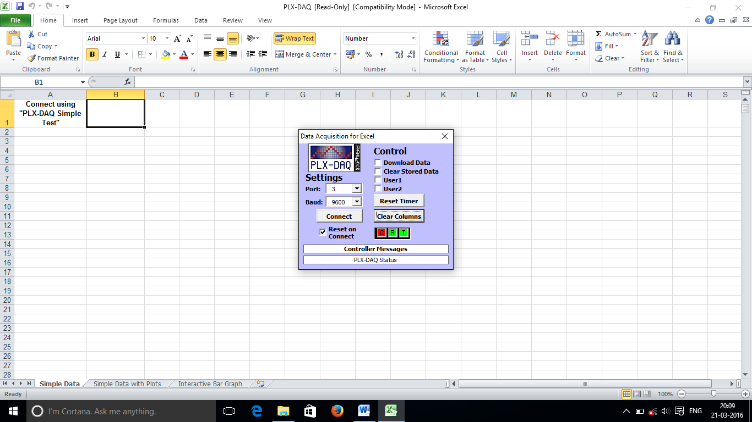

**Figure 6.2 PLX-DAQ Spread Sheet**

* + 1. **Features**
* Plot or graph data as it arrives in real-time using Microsoft Excel.
* Record up to 26 columns of data.
* Mark data with real-time (hh:mm:ss) or seconds since reset.
* Read/Write any cell on a worksheet.
* Read/Set any of 4 checkboxes on control interface.
* Baud rates up to 128K.

**CHAPTER 7**

**RESULTS AND OUTPUT**

The feasibility study for online weight measurement of citrus fruits using a low cost stationary weighing mechanism was performed for weight based grading and sorting. A Maltese Cross movement indexing mechanism was designed, developed and constructed for this purpose to perform the indexing operations. In this method, weight measurement of a fruit was done by allowing it to stay stationary on a simple weighing platform for a while during its movement. Unlike strain-gauge based load-cell which is used in dynamic weighing, a simple low-cost capacitive type weighing machine was used for weight measurement. This stationary weighing arrangement was designed to handle 1 fruit/sec with a 25W AC geared motor having an output speed of 40 rpm. However higher throughputs can be obtained by linking and properly synchronizing the indexing mechanism with the feeding and sorting conveyors. Though trials were done with citrus fruits, the weighing mechanism can be used for online weight measurement of other axi-symmetric fruits also.The fruits passing through the conveyor is shown in the Fig 7.1

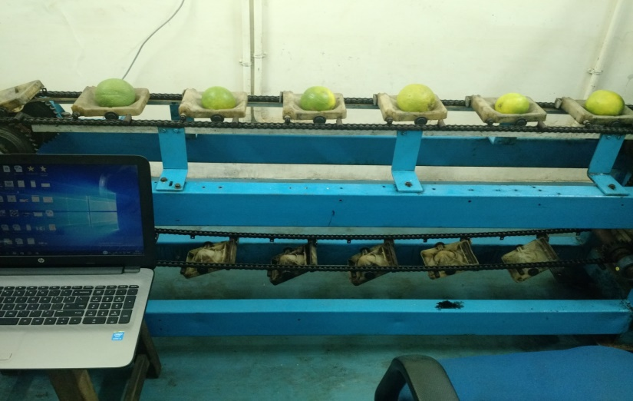

**Fig 7.1 Indexing of fruits**

After the fruits are being indexed it is then sensed by an IR sensor. Thr IR sensor keeps sensing as long as the fruit passes. The sensing of fruits by IR sensor is shown in fig 7.2

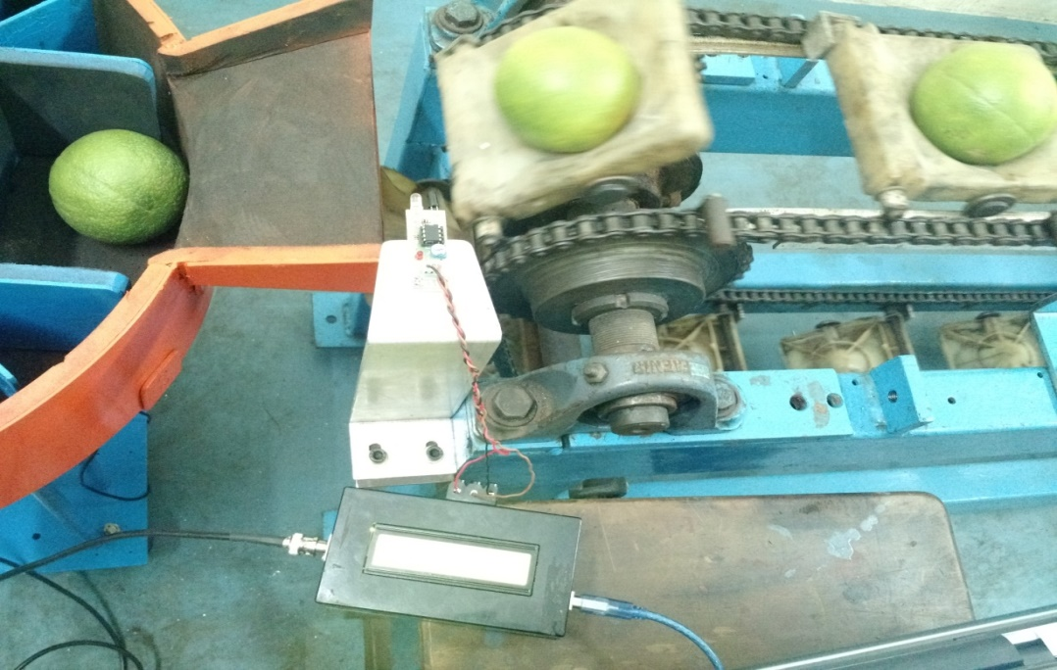

**Fig 7.2 sensing of fruits by IR sensor**

After the fruit is being sensed by the sensor its weight is then measured using a weighing machine. It is shown in fig 7.3.

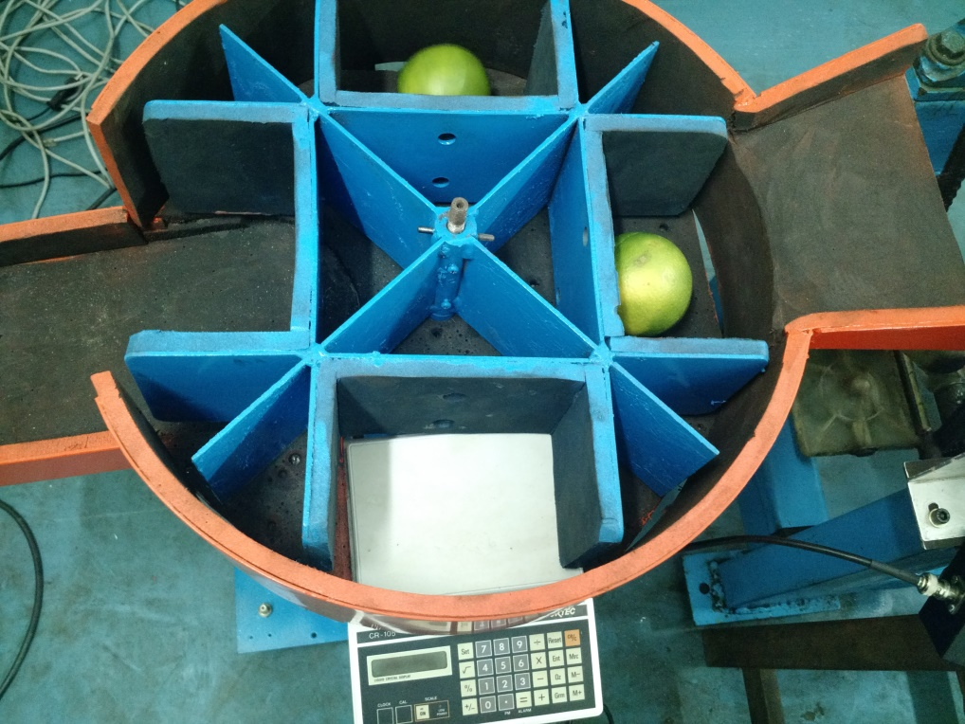

**Fig 7.3 Measurement of weight using weighing machine.**

As the fruit is being sensed by IR sensor the count gets incremented which is displayed in the LCD display. It is shown in fig 7.4

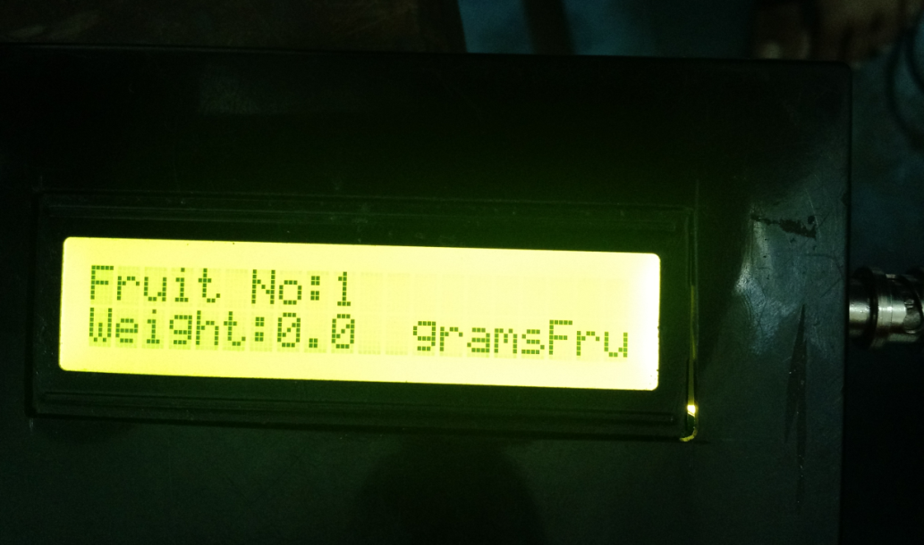

**Fig 7.4 Fruit count in LCD display**

The controllers used are shown in fig 7.5

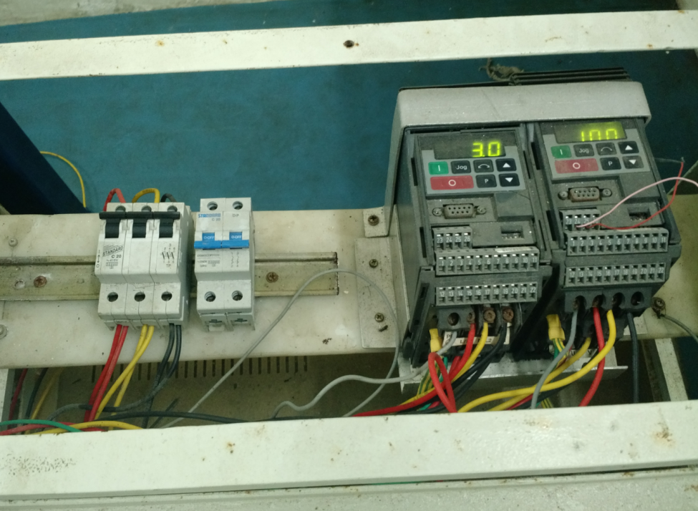

**Fig 7.5 controllers used**

**CHAPTER 8**

**CONCLUSION**

After the harvest, fruits of all types have to be sorted, packaged and transported. A wide range of technologies have been developed or refined over the years for sorting according to size, colour, shape, density and diameter. However, still manual actions/inspection by workers is being done. In this project, we have described a static weighing system that provides high performance. We implemented a full-fledged prototype model as a proof of concept to realise and understand the real time scenarios in SWM.

To overcome the drawbacks of dynamic weight measurement, we made an attempt to evaluate the performance of the system based on SWM. The fruits are indexed using an IR sensor. LCD is used for one-time display. Arduino receives the signal from IR sensor, DWM and displays the data in a excel sheet on PC using PLX-DAQ software. The deviations in the measured weight are reduced by applying 2σ limit. Overall system is based on automation and proves to be cost effective.

**FUTURE ENHANCEMENT**

This proposed system has a good prospect of application in fruit quantity detection and sorting areas. This SWM technique can be extended to sort all types of fruits by employing actuators which will grade the fruits according to their weights.

**APPENDIX I**

**TECHNICAL DATASHEET OF IR SENSOR**

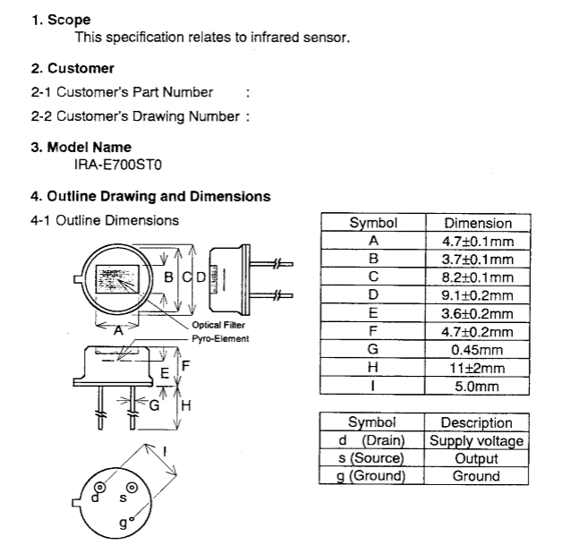

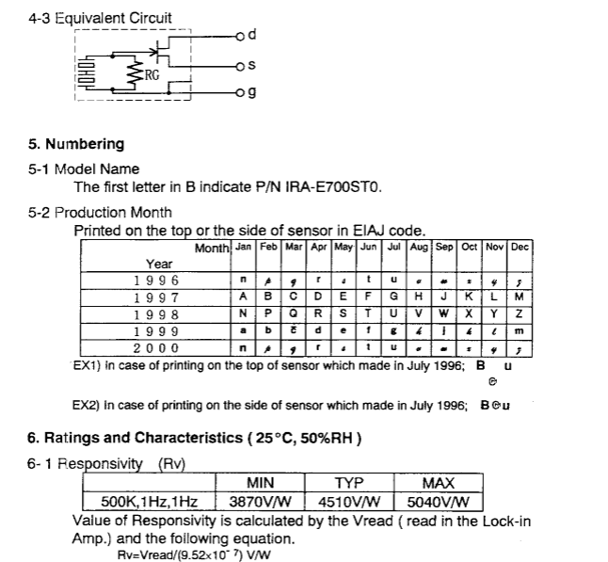

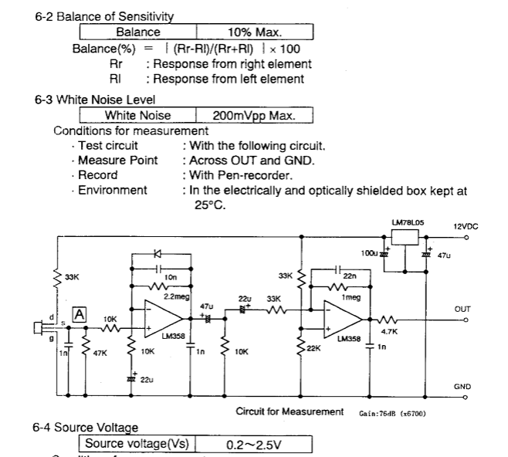

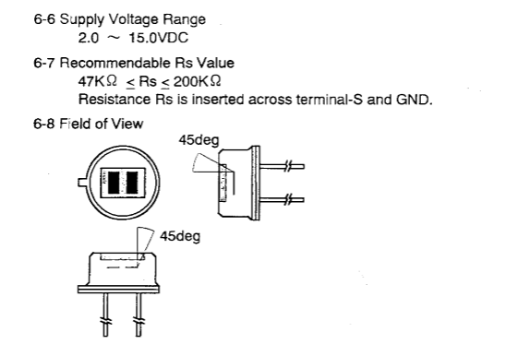

**APPENDIX II**

**SPECIFICATIONS- ARDUINO R3**

|  |  |
| --- | --- |
| Microcontroller | [ATmega328P](http://www.atmel.com/Images/doc8161.pdf) |
| Operating Voltage | 5V |
| Input Voltage (recommended) | 7-12V |
| Input Voltage (limit) | 6-20V |
| Digital I/O Pins | 14 (of which 6 provide PWM output) |
| PWM Digital I/O Pins | 6 |
| Analog Input Pins | 6 |
| DC Current per I/O Pin | 20 Ma |
| DC Current for 3.3V Pin | 50 Ma |
| Flash Memory | 32 KB (ATmega328P) of which 0.5 KB used by bootloader |
| SRAM | 2 KB (ATmega328P) |
| EEPROM | 1 KB (ATmega328P) |
| Clock Speed | 16 MHz |
| Length | 68.6 mm |
| Width | 53.4 mm |
| Weight | 25 g |

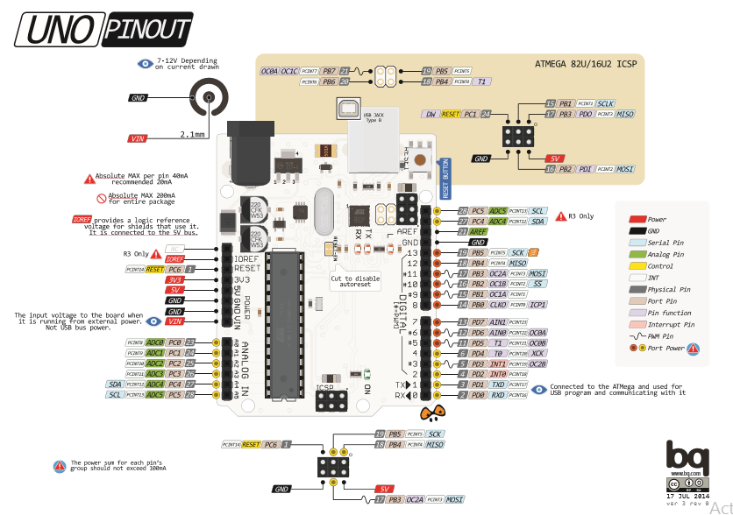

**REFERENCES**

**[**1**]**B. Sundaresan, R. Sridhar and S. Md. Iqbal. (2011)“Retrofit Automation of Weight based Sorter with Dynamic Electronic Weighing for Mangoes.” Trends in Industrial Measurements & Automation, 2011.TIMA2011*.* 7th International Conference on, Jan 6 – 8, 2011, pp.491-494

[2]Devendra A. Itole, Madhura R. Lodam, Sneha N. Panse, Vaishnavi S. Kulkarni,2015 “Fruit Quality Management and Sorting System**”,** International Journal of Advanced Research in Computer Engineering and Technology, volume 3, Issue 2, 2015.

[3]Khojastehnazhand, Mostafa, Mahmoud Omid, and Ahmad Tabatabaeefar.(2010) "Determination of tangerine volume using image processing methods.”International Journal of Food Properties 13.4 (2010): 760-770.

[4]Lino Antonio, Carlos Loureiro, Juliana Sanches, Inacio Maria and Dal Fabbro, "Image processing techniques for lemons and tomatoes classification", *Bragantia*, vol. 67, no. 3, pp. 785-789, 2008

[5]Loukik P. Narawade, Suresh S. Shendage,2015 **“**Weightbased Fruit Sorting System”,International Journal of Research in Computer Science and Management Studies,volume 3,Issue 3, March 2015.

[6]Sirisathitkul Yaowarat, Naphasorn Thumpen and Weerayut Puangtong, (2011)"Automated Chokun orange maturity soritng by colour grading", alailakJournal of Science and Technology (WJST), vol. 3, no. 2, pp. 195-205, 2011

[7]S. Gunasekaran and K. Ding,(1994) "Using computer vision for food quality evaluation", *Food Technology*, vol. 6, pp. 151-154, 1994

[8].U Ahmad, S Mardison, R Tjahjohutomo and A. Nurhasanah, (2010)"Development of automatic grading machine prototype for citrus using image processing", Australian Journal of Agriculture Engineering, o. 5, pp. 165-169, 2010